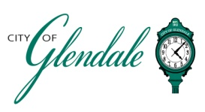
NOTICE OF MEETING
WEDNESDAY, APRIL 9, 2025 – 6:00 PM
PLAN COMMISSION
TENTATIVE AGENDA

The Architectural Review Board meeting will immediately follow the Plan Commission meeting.

- MEETING CALLED TO ORDER

- ROLL CALL

- APPROVAL OF MINUTES FROM MARCH 12, 2025

- SPECIAL USE PERMIT FOR OUTDOOR DINING: GLENDALE GRIND, 421 N. SAPPINGTON RD.

- DEVELOPMENT PLAN REVIEW: 1320 W. LOCKWOOD AVE

- ADJOURNMENT

This meeting will be open to the public.

______________________________
Gabrielle Macaluso
Deputy City Clerk

POSTED: 4:00 P.M., April 3, 2025

